

‘Light and Movement’

An exhibition of watercolour paintings by Mike Jeffries

Raising funds for Lewis-Manning Hospice Care and Lighthouse

3rd – 26th September 2026

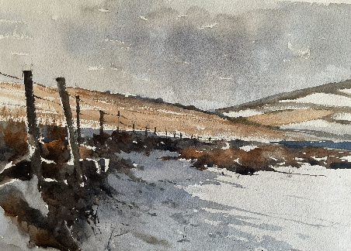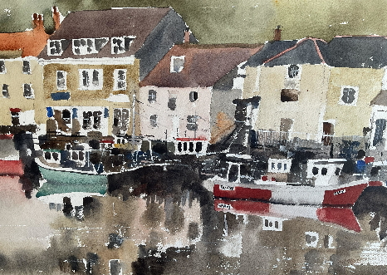
1 Winter in the Dales 2.Padstow Reflections
47 x 32 cm £300 47 x 32 cm £350

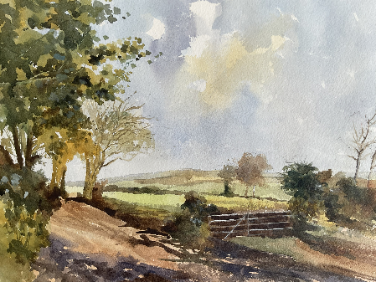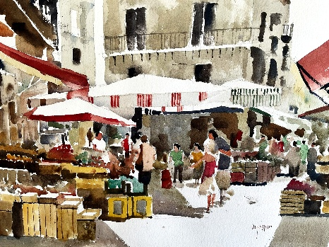
3. Towards the Downs 4. Market Day
47 x 32 cm £300 47 x 32 cm £350

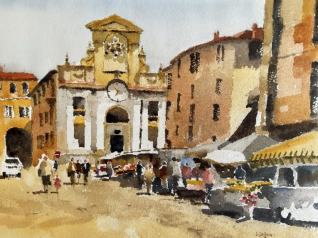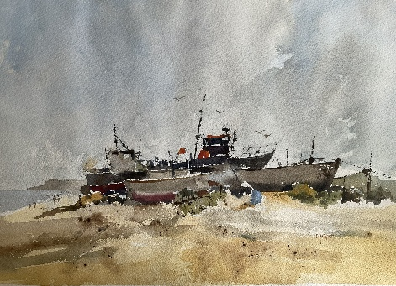
5. Spoletto Market 6. High and Dry
47 x 32 cm £350 47 x 32 cm £300

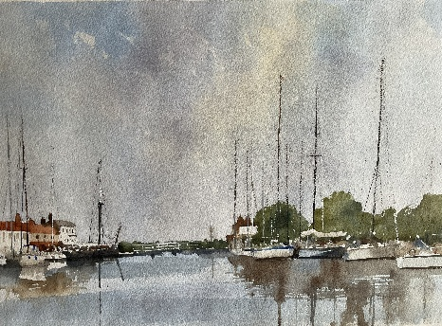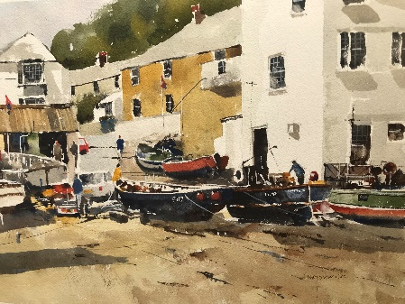
7. Heybridge Basin 8. Cadgwith Cornwall
47 x 32 cm £300 47 x 32 cm £350

All funds raised will be donated to Lewis-Manning Hospice Care and Lighthouse.
To purchase paintings, please call the box office on 01202 280000.

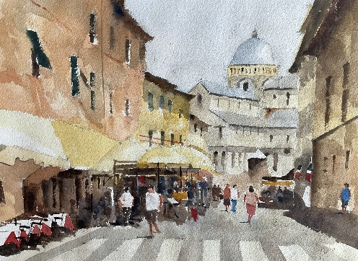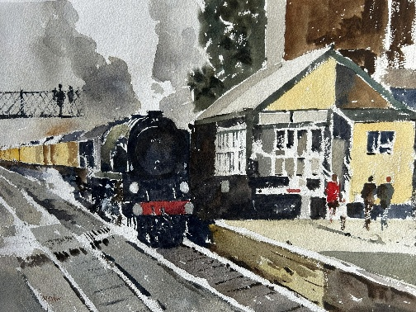
9. Piazza del Duomo Pisa 10. Station Halt
47 x 32 cm £300 47 x 32 cm £350

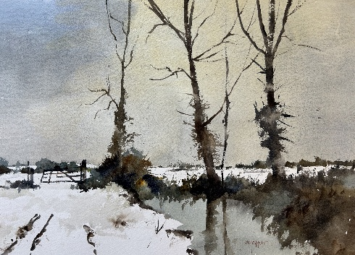 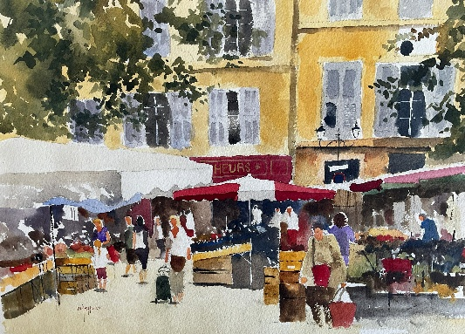 11. Norfolk Snow 12. Aix en Provence
47 x 32 cm £300 47 x 32 cm £350

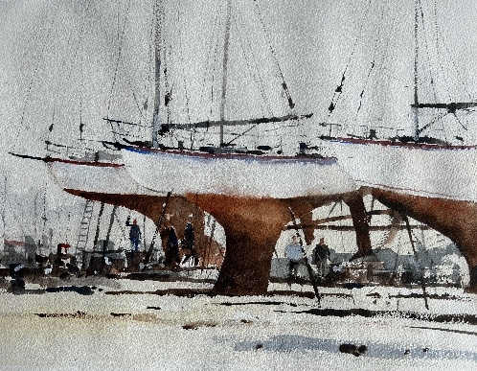 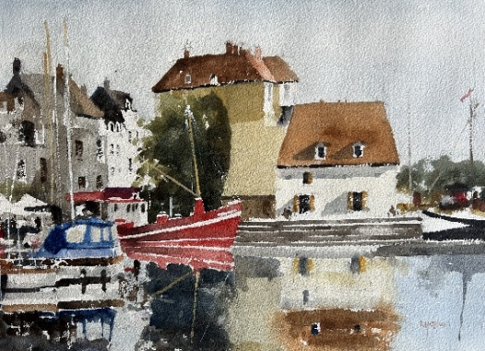 13. Lift Out 14. Honfleur 1
47 x 32cm £300 47 x 32 cm £300

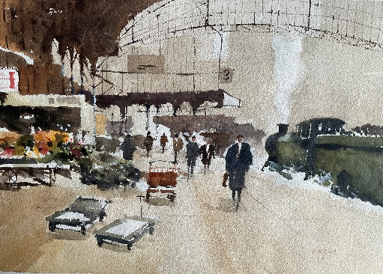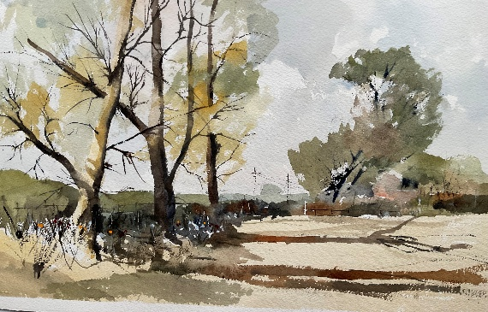
15. The Train Now Arriving 16. Long Shadows
47 x 32 cm £350 47 x 32 cm £300
All funds raised will be donated to Lewis-Manning Hospice Care and Lighthouse.
To purchase paintings, please call the box office on 01202 280000.

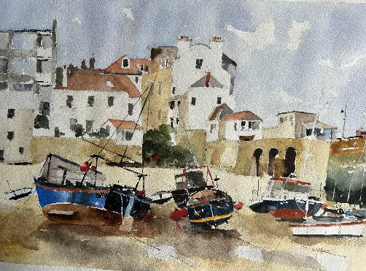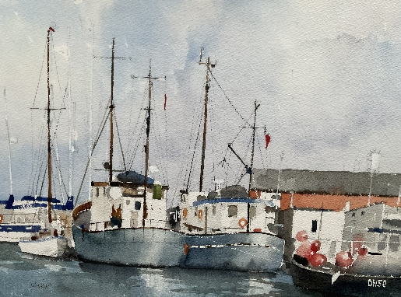
17. Low Tide at St Ives 18. Poole Fishing Boats
47 x 32 cm £325 47 x 32 cm £325

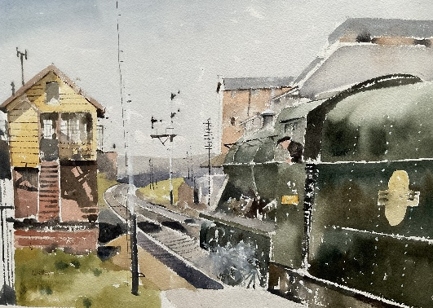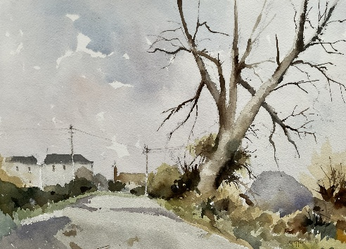
19. Ready to Go 20. Out of Town
47 x 32 cm £350 47 x 32 cm £300

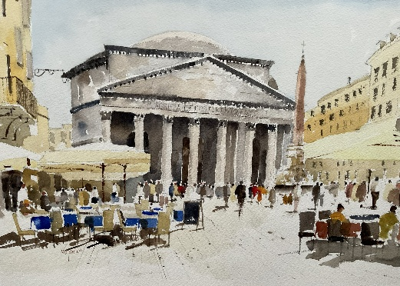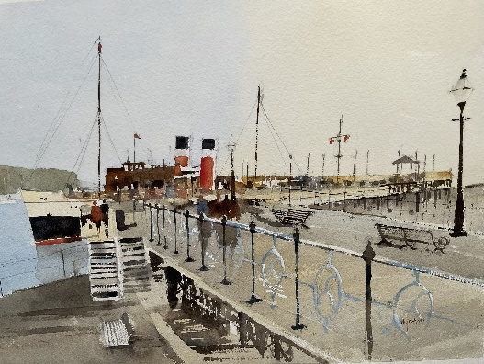
21. Pantheon Rome 22. Waverley at Swanage
47 x 32 cm £350 47 x 32 cm £300

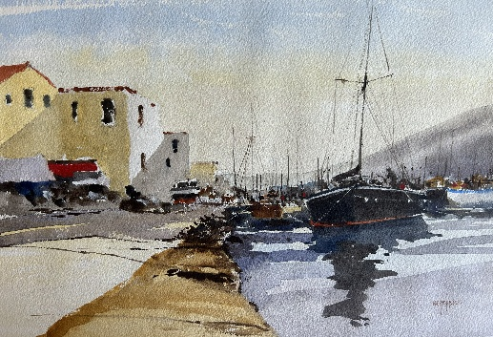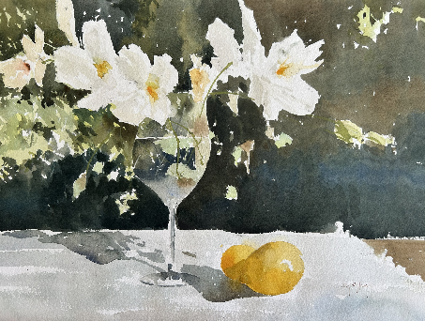
23. In the Greek Islands 24. Flowers without Wine
45 x 29 cm £275 47 x 32 cm £300
All funds raised will be donated to Lewis-Manning Hospice Care and Lighthouse.
To purchase paintings, please call the box office on 01202 280000.

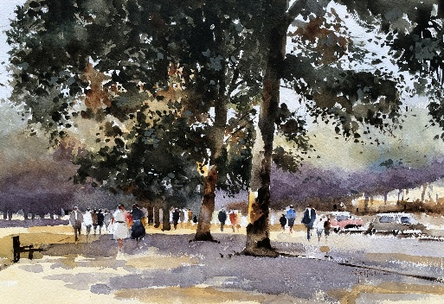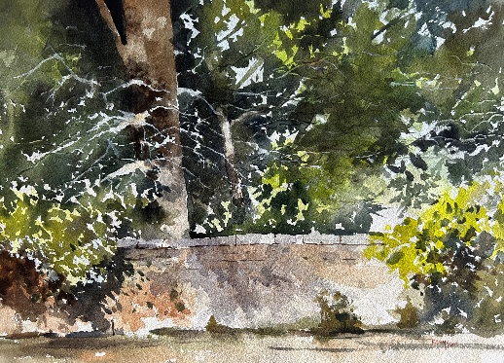
25. Hyde Park Strollers 26. Sunlight and Shade
47 x 32 cm £300 47 x 32 cm £300

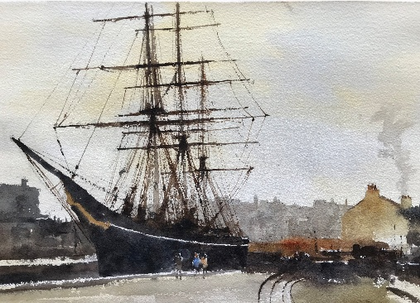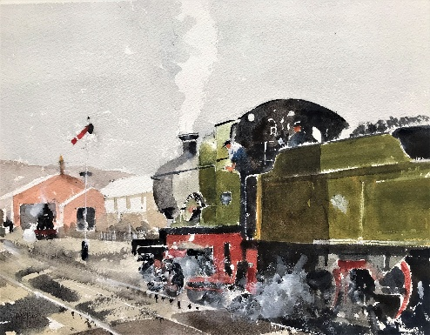
27. Cutty Sark 28. End of the Day
47 x 32 cm £300 47 x 32 cm £300

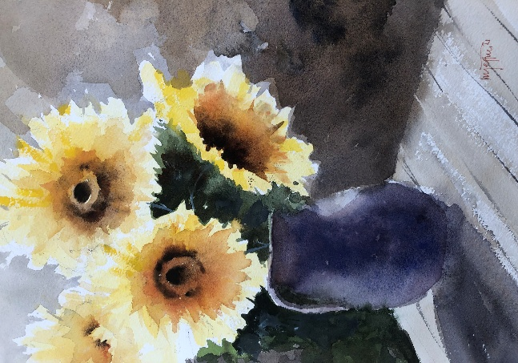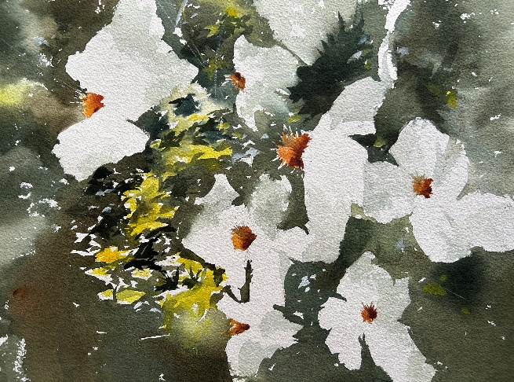
29.Sunflowers 30. Daisies
42 x 34 cm £275 42 x 34 cm £275
All funds raised will be donated to Lewis-Manning Hospice Care and Lighthouse.
To purchase paintings, please call the box office on 01202 280000.
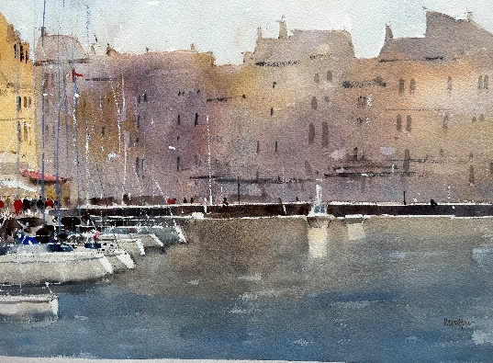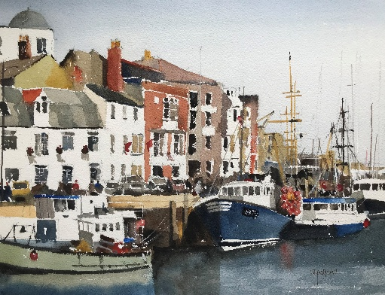
31. Honfleur 32. Weymouth Quay
47 x 32 cm £350 47 x 32 cm £350

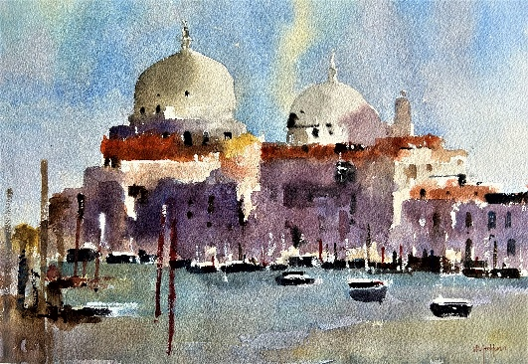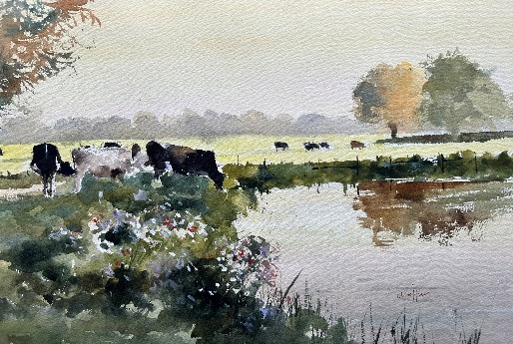
33. Grand Canal Venice 34. A Quick Drink
47 x 32 cm £325 47 x 32 cm £325

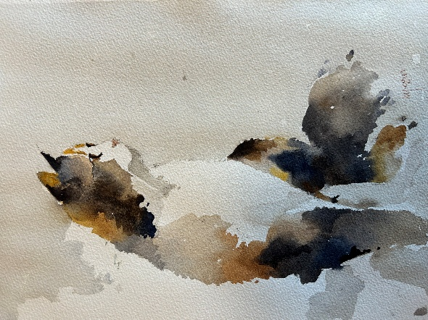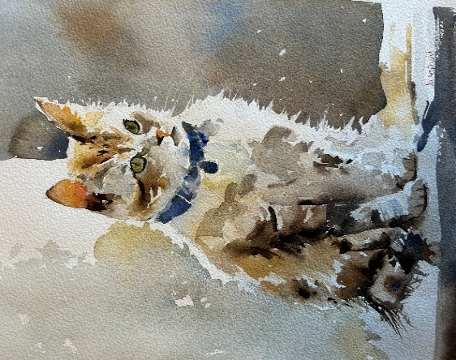
35. Tabby 36. Mouser
32 x 24 cm £175 32 x 24 cm £175

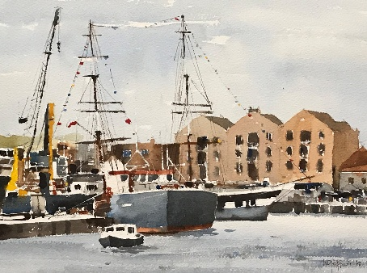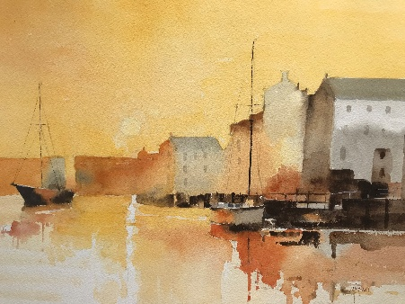
37. Sail and Steam Poole 38. Harbour Sunrise
47 x 32 cm £325 45 x 29 cm £300
All funds raised will be donated to Lewis-Manning Hospice Care and Lighthouse.
To purchase paintings, please call the box office on 01202 280000.

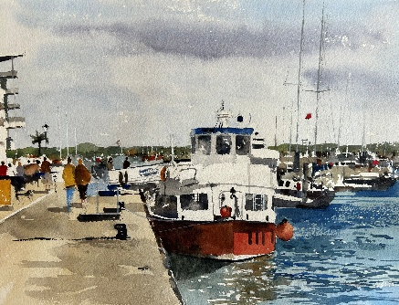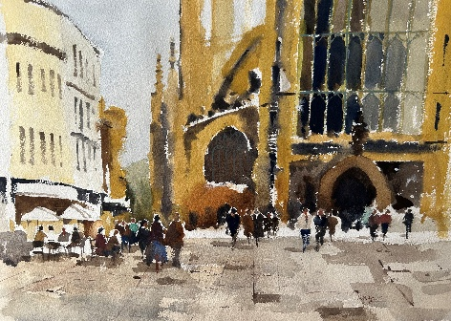
39. Purbeck Gem 40. Bath Abbey
47 x 32 cm £350 45 x 32 cm £300

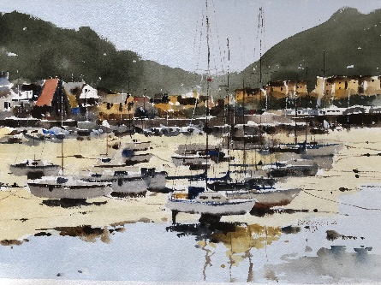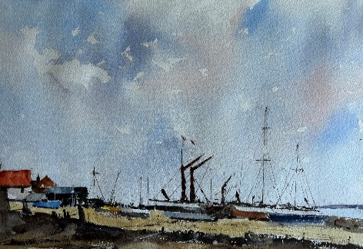
41.St Aubins Harbour Jersey 42. Beached
47 x 32 cm £300 47 x 32 cm £300

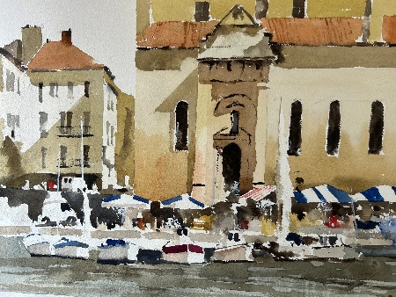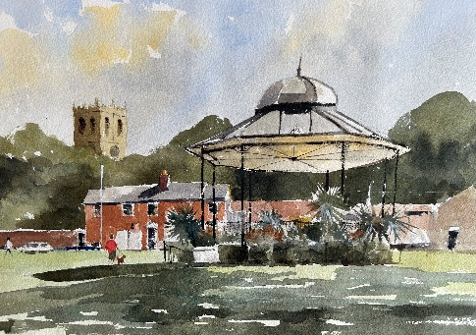
43. Chioggia Venice 44. Christchurch
47 x 32 cm £300 47 x 32 cm £300

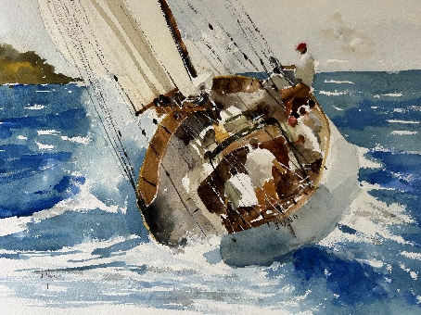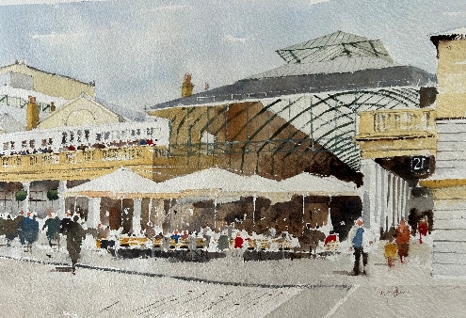
45. Broad Reach 46. Covent Garden 1
47 x 32 cm £300 47 x 32 cm £350

All funds raised will be donated to Lewis-Manning Hospice Care and Lighthouse.
To purchase paintings, please call the box office on 01202 280000.
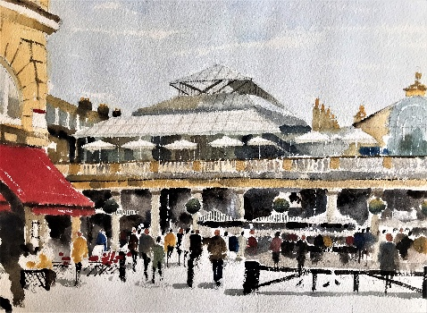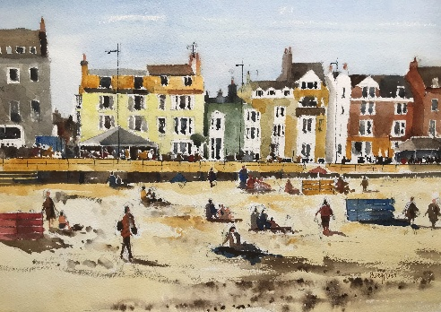
47. Covent Garden 2 48. Weymouth Beach
47 x 32 cm £350 47 x 32 cm £350

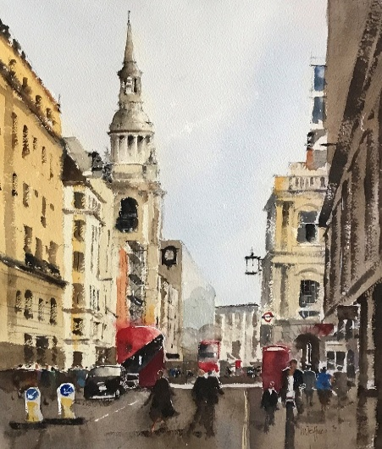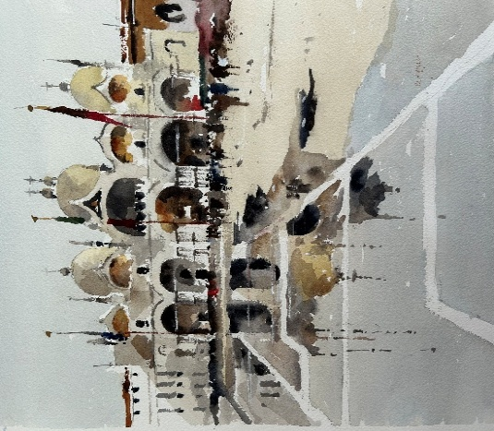
49. Cheapside 50 .High Tide St Marks
47 x 32 cm £350 45 x 32 cm £325

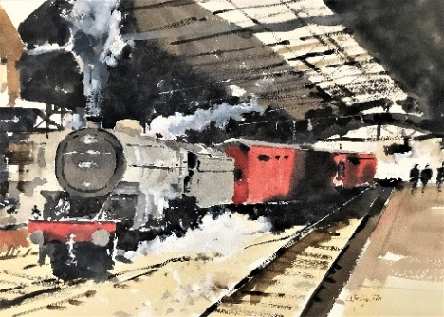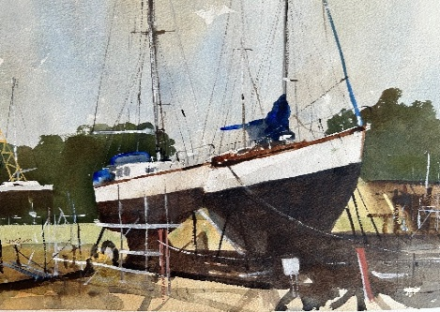
51. Through Train 52. Awaiting Attention
47 x 32 cm £300 43 x 33 cm £275

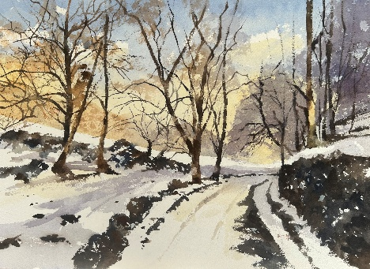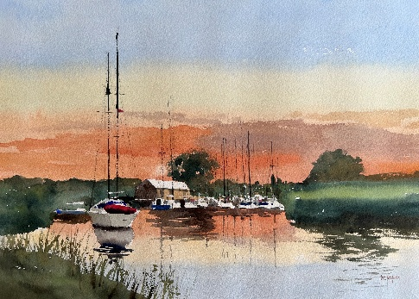
53. Winter Vale 54. Frome Sunset 47 x 32 cm £325 47 x 32 cm £350
All funds raised will be donated to Lewis-Manning Hospice Care and Lighthouse.
To purchase paintings, please call the box office on 01202 280000.

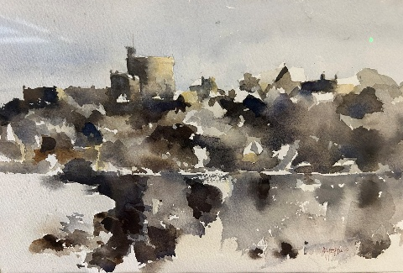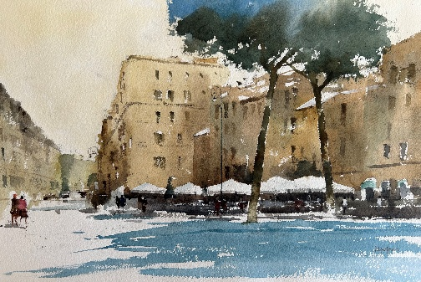
55. Winter at Windsor 56. Near the Colloseum
32 x 24 cm £175 47 x 32 cm £350

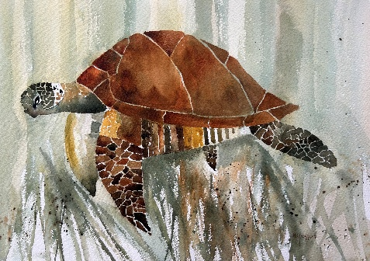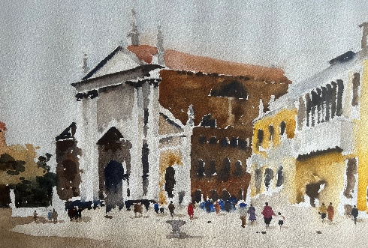
57. Swimming with the Turtles 58. Santa Stephano Venice
47 x 32 cm £350 45 x 34 cm £300

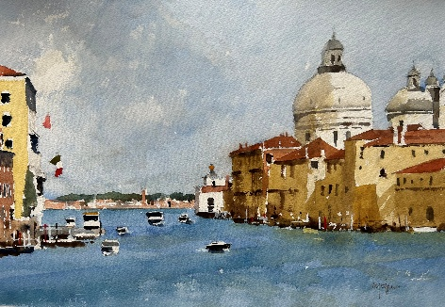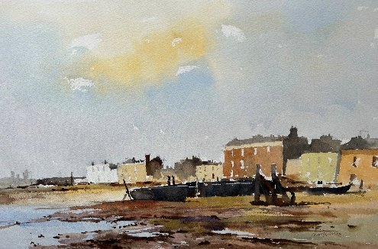
59.The Salute Venice 60. Strand on the Green
47 x 32 cm £300 47 x 32 cm £300

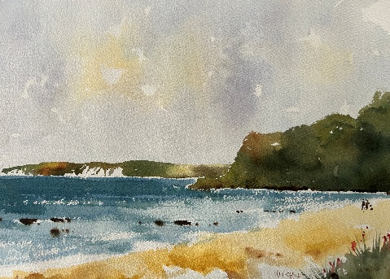 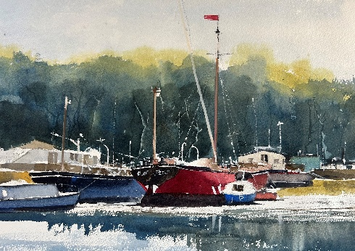 61. Old Harry from Studland 62. Waiting for the Tide
47 x 32 cm £300 47 x 32 cm £300
All funds raised will be donated to Lewis-Manning Hospice Care and Lighthouse.
To purchase paintings, please call the box office on 01202 280000.
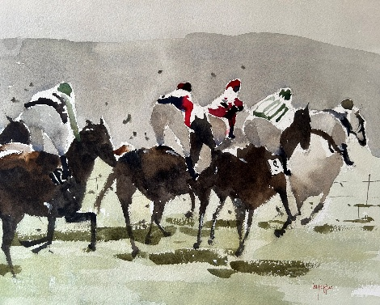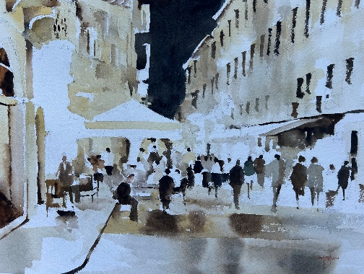
63. Point to Point 64. Paris at Night
45 x 34 cm £275 47 x 32 cm £300

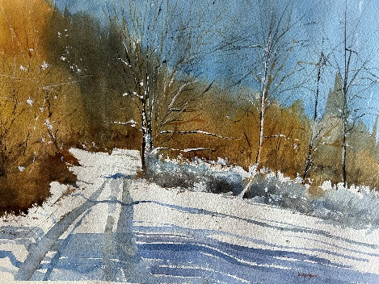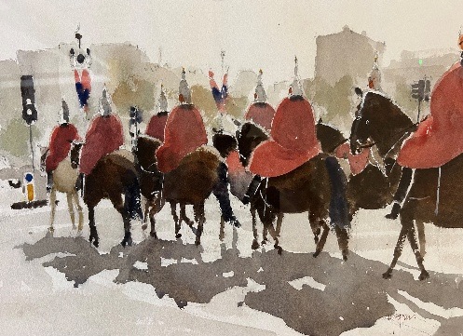
65. Winter Tracks 66. Changing of the Guard
47 x 32 cm £300 47 x 32 cm £350

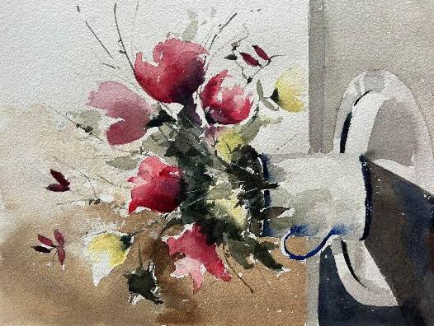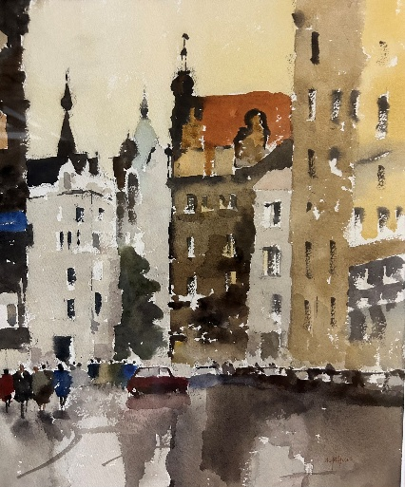
67. The Enamel Jug 66. Prague
32 x 24 cm £175 45 x 34 cm £275

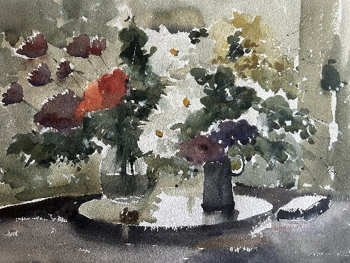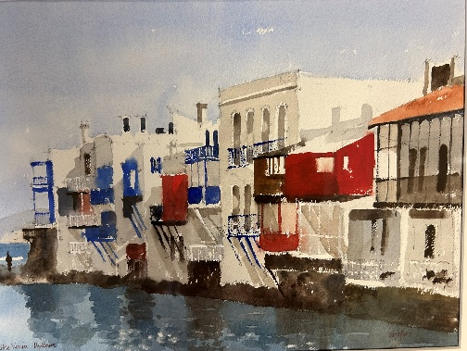
67. By the Window 68. Little Venice
47 x 32 cm £275 45 x 29 cm £300
All funds raised will be donated to Lewis-Manning Hospice Care and Lighthouse.
To purchase paintings, please call the box office on 01202 280000.

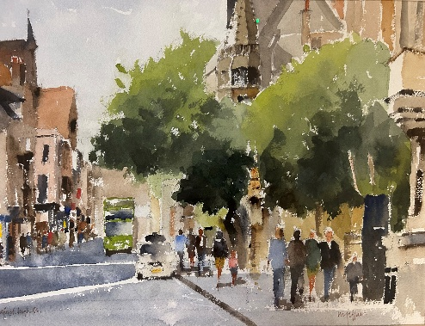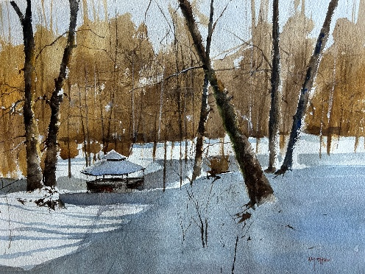
69. Oxford High Street 70. Snow Bothy
47 x 32 cm £300 47 x 32 cm £275

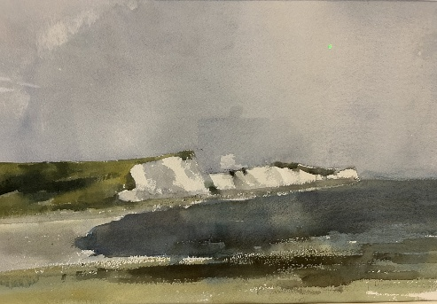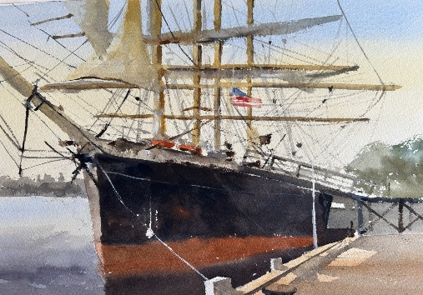
71. The Seven Sisters 72. US Sail
47 x 32 cm £275 47 x 32 cm £275

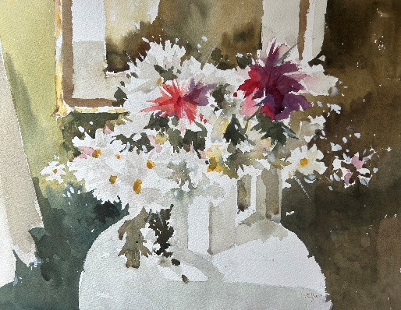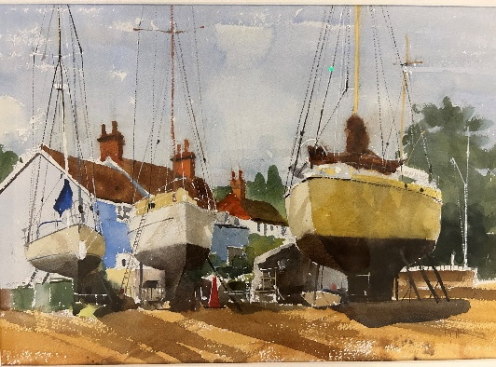
73. Red and White 74. Harry King’s Boatyard
47 x 32cm £300 47 x 32 cm £275

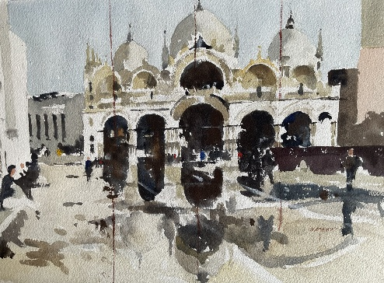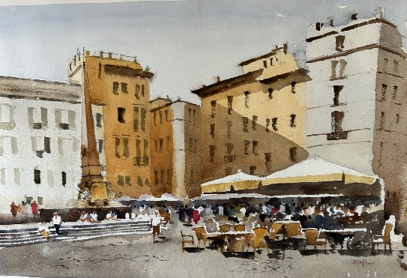
75. Early Light St Marks 76. Pantheon Piazza
45 x 30 cm £300 47 x 32 £350
All funds raised will be donated to Lewis-Manning Hospice Care and Lighthouse.
To purchase paintings, please call the box office on 01202 280000.
Lighthouse is an independent arts charity serving Dorset and the wider region, based in an iconic building at the heart of Poole. We bring theatre, music, dance, comedy, film and visual arts together under one roof. We believe everyone should have access to the arts, regardless of background or circumstances, and work to break down barriers, create opportunities and enable more people to experience the joy, connection and inspiration they can bring.

lighthousepoole.co.uk

Registered Charity Number 275961

Lewis-Manning Hospice Care is an independent local Dorset charity providing extraordinary care to people and their loved ones facing a life-limiting illness. We support over 1400 patients and families every year in their homes, virtually, and at our hubs across Swanage, Wareham, Poole, Wimborne, Christchurch and Bournemouth.

lewis-manning.org.uk

Registered Charity Number 1120193

