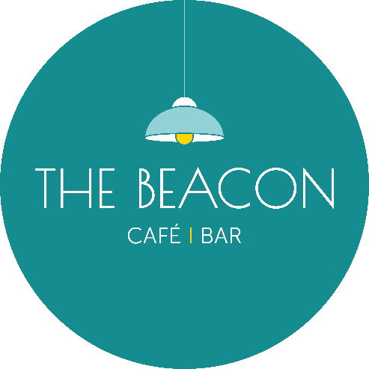
Opening Times – July 2026
Day | Date | Lunch | Evening
Wednesday | 01/07/26 | 10.00-15.00 | 17.00-19.30
Thursday | 02/07/26 | 10.00-15.00 | Closed
Friday | 03/07/26 | 10.00-15.00 | Closed
Saturday | 04/07/26 | 10.00-15.00 | Closed
Sunday | 05/07/26 | Closed | Closed
Monday | 06/07/26 | Closed | Closed
Tuesday | 07/07/26 | 10.00-15.00 | Closed
Wednesday | 08/07/26 | 10.00-18.30 | Closed
Thursday | 09/07/26 | 10.00-15.00 | Closed
Friday | 10/07/26 | 10.00-15.00 | 17.00-19.30
Saturday | 11/07/26 | 10.00-15.00 | 17.00-19.30
Sunday | 12/07/26 | Closed | Closed
Monday | 13/07/26 | Closed | Closed
Tuesday | 14/07/26 | 10.00-15.00 | Closed
Wednesday | 15/07/26 | 10.00-15.00 | Closed
Thursday | 16/07/26 | 10.00-15.00 | Closed
Friday | 17/07/26 | 10.00-15.00 | 17.00-19.30
Saturday | 18/07/26 | 10.00-15.00 | 17.00-19.30
Sunday | 19/07/26 | Closed | Closed
Monday | 20/07/26 | Closed | Closed
Tuesday | 21/07/26 | 10.00-15.00 | Closed
Wednesday | 22/07/26 | 10.00-15.00 | Closed
Thursday | 23/07/26 | 10.00-15.00 | Closed
Friday | 24/07/26 | 10.00-15.00 | Closed
Saturday | 25/07/26 | 10.00-15.00 | 17.00-19.30
Sunday | 26/07/26 | Closed | Closed
Monday | 27/07/26 | Closed | Closed
Tuesday | 28/07/26 | 10.00-15.00 | Closed
Wednesday | 29/07/26 | 10.00-15.00 | Closed
Thursday | 30/07/26 | 10.00-15.00 | Closed
Friday | 31/07/26 | 10.00-15.00 | 17.00-19.30
*Café Only/No Hot Food

