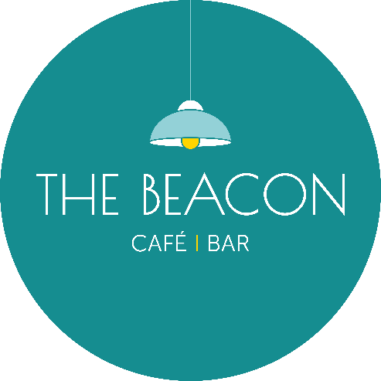
Opening Times – May 2026
Day | Date | Lunch | Evening
Friday | 01/05/26 | 10.00-15.00 | 17.00-19.30
Saturday | 02/05/26 | 10.00-15.00 | 17.00-19.30
Sunday | 03/05/26 | Closed | Closed
Monday | 04/05/26 | 12.00-18.00* | Closed
Tuesday | 05/05/26 | 10.00-15.00 | 17.00-19.30
Wednesday | 06/05/26 | 10.00-15.00 | 17.00-19.30
Thursday | 07/05/26 | 10.00-15.00 | 17.00-19.30
Friday | 08/05/26 | 10.00-15.00 | Closed
Saturday | 09/05/26 | 10.00-15.00 | 17.00-19.30
Sunday | 10/05/26 | 10.00-15.00* | 17.00-19.30
Monday | 11/05/26 | Closed | Closed
Tuesday | 12/05/26 | 10.00-15.00 | Closed
Wednesday | 13/05/26 | 10.00-15.00 | 17.00-19.30
Thursday | 14/05/26 | 10.00-15.00 | Closed
Friday | 15/05/26 | 10.00-15.00 | 17.00-19.30
Saturday | 16/05/26 | 10.00-15.00 | 17.00-19.30
Sunday | 17/05/26 | Closed | Closed
Monday | 18/05/26 | Closed | Closed
Tuesday | 19/05/26 | 10.00-15.00 | Closed
Wednesday | 20/05/26 | 10.00-15.00 | 17.00-19.30
Thursday | 21/05/26 | 10.00-15.00 | 17.00-19.30
Friday | 22/05/26 | 10.00-15.00 | 17.00-19.30
Saturday | 23/05/26 | 10.00-15.00 | 17.00-19.30
Sunday | 24/05/26 | Closed | Closed
Monday | 25/05/26 | Closed | Closed
Tuesday | 26/05/26 | 10.00-15.00 | Closed
Wednesday | 27/05/26 | 10.00-15.00 | Closed
Thursday | 28/05/26 | 10.00-15.00 | Closed
Friday | 29/05/26 | 10.00-15.00 | Closed
Saturday | 30/05/26 | 10.00-15.00 | 17.00-19.30
Sunday | 31/05/26 | Closed | Closed
*Café Only/No Hot Food

