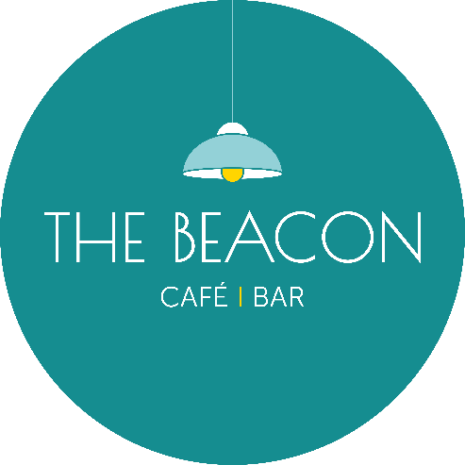
Opening Times – June2026
Day | Date | Lunch | Evening
Monday | 01/06/26 | Closed | Closed
Tuesday | 02/06/26 | 10.00-15.00 | 17.00-19.30
Wednesday | 03/06/26 | 10.00-16.00 | Closed
Thursday | 04/06/26 | 10.00-15.00 | 17.00-19.30
Friday | 05/06/26 | 10.00-15.00 | 17.00-19.30
Saturday | 06/06/26 | 10.00-15.00 | 17.00-19.30
Sunday | 07/06/26 | Closed | Closed
Monday | 08/06/26 | Closed | Closed
Tuesday | 09/06/26 | 10.00-15.00 | 17.00-19.30
Wednesday | 10/06/26 | 10.00-15.00 | 17.00-19.30
Thursday | 11/06/26 | 10.00-15.00 | 17.00-19.30
Friday | 12/06/26 | 10.00-15.00 | Closed
Saturday | 13/06/26 | 10.00-15.00 | 17.00-19.30
Sunday | 14/06/26 | 12.00-17.00* | Closed
Monday | 15/06/26 | Closed | Closed
Tuesday | 16/06/26 | 10.00-15.00 | Closed
Wednesday | 17/06/26 | 10.00-15.00 | Closed
Thursday | 18/06/26 | 10.00-15.00 | 17.00-19.30
Friday | 19/06/26 | 10.00-15.00 | 17.00-19.30
Saturday | 20/06/26 | 10.00-15.00 | 17.00-19.30
Sunday | 21/06/26 | Closed | Closed
Monday | 22/06/26 | Closed | Closed
Tuesday | 23/06/26 | 10.00-15.00 | 17.00-19.30
Wednesday | 24/06/26 | 10.00-15.00 | 17.00-19.30
Thursday | 25/06/26 | 10.00-15.00 | 17.00-19.30
Friday | 26/06/26 | 10.00-15.00 | Closed
Saturday | 27/06/26 | 10.00-15.00 | Closed
Sunday | 28/06/26 | Closed | Closed
Monday | 29/06/26 | Closed | Closed
Tuesday | 30/06/26 | 10.00-15.00 | 17.00-19.30
*Café Only/No Hot Food

