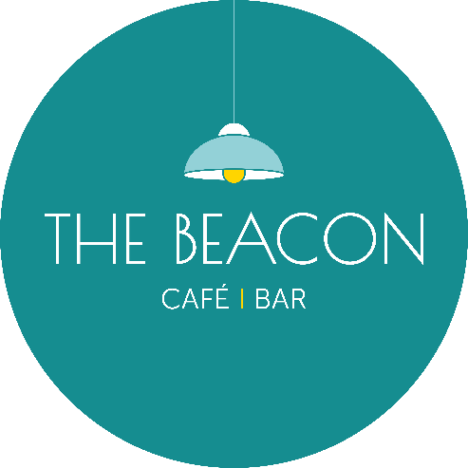
Opening Times – April 2026
Day | Date | Lunch | Evening
Wednesday | 01/04/26 | 10.00-15.00 | Closed
Thursday | 02/04/26 | 10.00-15.00 | 17.00-19.30
Friday | 03/04/26 | Closed | Closed
Saturday | 04/04/26 | Closed | Closed
Sunday | 05/04/26 | Closed | Closed
Monday | 06/04/26 | Closed | Closed
Tuesday | 07/04/26 | 10.00-15.00 | Closed
Wednesday | 08/04/26 | 10.00-15.00 | Closed
Thursday | 09/04/26 | 10.00-15.00 | Closed
Friday | 10/04/26 | 10.00-15.00 | 17.00-19.30
Saturday | 11/04/26 | 10.00-15.00 | 17.00-19.30
Sunday | 12/04/26 | Closed | Closed
Monday | 13/04/26 | Closed | Closed
Tuesday | 14/04/26 | 10.00-15.00 | Closed
Wednesday | 15/04/26 | 10.00-15.00 | 17.00-19.30
Thursday | 16/04/26 | 10.00-15.00 | 17.00-19.30
Friday | 17/04/26 | 10.00-15.00 | Closed
Saturday | 18/04/26 | 10.00-15.00 | Closed
Sunday | 19/04/26 | 10.00-15.00* | Closed
Monday | 20/04/26 | Closed | Closed
Tuesday | 21/04/26 | 10.00-15.00 | 17.00-19.30
Wednesday | 22/04/26 | 10.00-15.00 | 17.00-19.30
Thursday | 23/04/26 | 10.00-15.00 | 17.00-19.30
Friday | 24/04/26 | 10.00-15.00 | 17.00-19.30
Saturday | 25/04/26 | 10.00-15.00 | 17.00-19.30
Sunday | 26/04/26 | Closed | Closed
Monday | 27/04/26 | Closed | 17.00-19.30*
Tuesday | 28/04/26 | 10.00-15.00 | 17.00-19.30
Wednesday | 29/04/26 | 10.00-15.00 | 17.00-19.30
Thursday | 30/04/26 | 10.00-15.00 | 17.00-19.30
Friday | 01/05/26 | 10.00-15.00 | 17.00-19.30
*Café Only/No Hot Food

