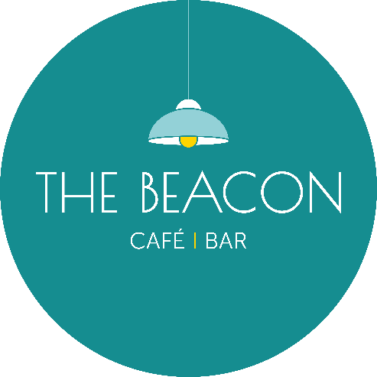
Opening Times – January 2026
Day | Date | Lunch | Evening
Thursday | 1/01/26 | Closed | Closed
Friday | 2/01/26 | *13.00-18.00 | Closed
Saturday | 3/01/26 | *13.00-18.00 | Closed
Sunday | 4/01/26 | *10.00-15.00 | Closed
Monday | 5/01/26 | Closed | Closed
Tuesday | 6/01/26 | *10.00-15.00 | Closed
Wednesday | 7/01/26 | 10.00-15.00 | Closed
Thursday | 8/01/26 | 10.00-15.00 | 17.00-19.30
Friday | 9/01/26 | 10.00-15.00 | Closed
Saturday | 10/01/26 | 10.00-15.00 | 17.00-19.30
Sunday | 11/01/26 | Closed | Closed
Monday | 12/01/26 | Closed | Closed
Tuesday | 13/01/26 | 10.00-15.00 | Closed
Wednesday | 14/01/26 | 10.00-15.00 | 17.00-19.30
Thursday | 15/01/26 | 10.00-15.00 | 17.00-19.30
Friday | 16/01/26 | 10.00-15.00 | 17.00-19.30
Saturday | 17/01/26 | 10.00-15.00 | 17.00-19.30
Sunday | 18/01/26 | *12.00-15.00 | Closed
Monday | 19/01/26 | Closed | Closed
Tuesday | 20/01/26 | 10.00-15.00 | Closed
Wednesday | 21/01/26 | 10.00-15.00 | 17.00-19.30
Thursday | 22/01/26 | 10.00-15.00 | 17.00-19.30
Friday | 23/01/26 | 10.00-15.00 | Closed
Saturday | 24/01/26 | 10.00-15.00 | Closed
Sunday | 25/01/26 | *10.00-16.00 | Closed
Monday | 26/01/26 | Closed | Closed
Tuesday | 27/01/26 | 10.00-15.00 | 17.00-19.30
Wednesday | 28/01/26 | 10.00-15.00 | 17.00-19.30
Thursday | 29/01/26 | 10.00-15.00 | 17.00-19.30
Friday | 30/01/26 | 10.00-15.00 | 17.00-19.30
Saturday | 31/01/26 | 10.00-15.00 | 17.00-19.30
*Café Only/No Hot Food

