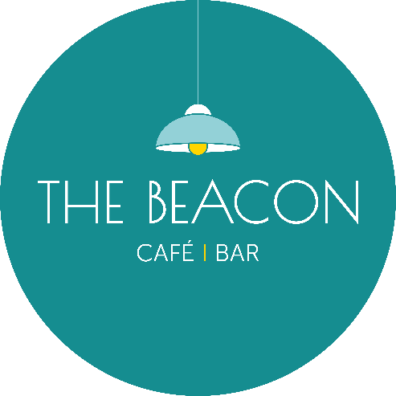
Opening Times – December 2025
Day | Date | Lunch | Evening
Monday | 1/12/25 | Closed | Closed
Tuesday | 2/12/25 | 09.45-15.00 | Closed
Wednesday | 3/12/25 | 09.45-15.00 | 17.00- 19.30
Thursday | 4/12/25 | 10.00-15.00 | 17.00-19.30
Friday | 5/12/25 | 10.00-15.00 | 17.00-19.30
Saturday | 6/12/25 | 10.00-15.00 | 17.00-19.30
Sunday | 7/12/25 | *10.00-15.00 | Closed
Monday | 8/12/25 | Closed | Closed
Tuesday | 9/12/25 | 09.45-15.00 | Closed
Wednesday | 10/12/25 | 09.45-15.00 | 17.00-19.30
Thursday | 11/12/25 | 10.00-15.00 | 17.00-19.30
Friday | 12/12/25 | 10.00-15.00 | 17.00-19.30
Saturday | 13/12/25 | 10.00-15.00 | 17.00-19.30
Sunday | 14/12/25 | *10.00-15.00 | Closed
Monday | 15/12/25 | Closed | Closed
Tuesday | 16/12/25 | 10.00-15.00 | 17.00-19.30
Wednesday | 17/12/25 | 10.00-15.00 | 17.00-19.30
Thursday | 18/12/25 | 10.00-15.00 | 17.00-19.00
Friday | 19/12/25 | 10.00-15.00 | Closed
Saturday | 20/12/25 | 10.00-15.00 | 17.00-19.30
Sunday | 21/12/25 | 13.00-18.00 | Closed
Monday | 22/12/25 | *10.00-15.00 | *16.00-19.30
Tuesday | 23/12/25 | 10.00-15.00 | 17.00-19.30
Wednesday | 24/12/25 | 10.00-15.00 | Closed
Thursday | 25/12/25 | Closed | Closed
Friday | 26/12/25 | Closed | Closed
Saturday | 27/12/25 | 13.00-18.00 | Closed
Sunday | 28/12/25 | *13.00-18.00 | Closed
Monday | 29/12/25 | *13.00-18.00 | Closed
Tuesday | 30/12/25 | 13.00-15.00 | 17.00-19.00
Wednesday | 31/12/25 | 10.00-15.00 | Closed
Thursday | 01/01/26 | Closed | Closed
*Café Only/No Hot Food

