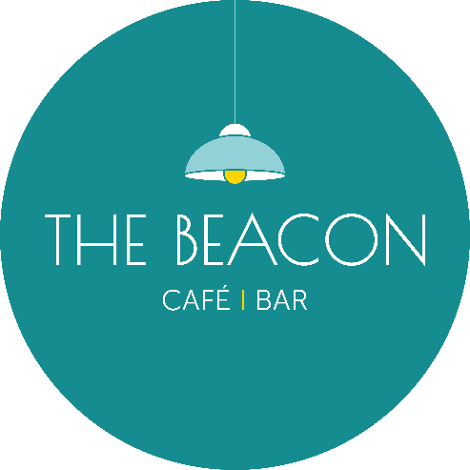

Opening Times – June 2025

|  |  |  |  |
| --- | --- | --- | --- |
| Day | Date | Lunch | Evening |
| Sunday | 01.06.25 | Closed | Closed |
| Monday | 02.06.25 | Closed | Closed |
| Tuesday | 03.06.25 | 10.00-15.30 | 17.00-20.00 |
| Wednesday | 04.06.25 | *10.00-15.30 | *17.00-20.00 |
| Thursday | 05.06.25 | *10.00-15.30 | *17.00-20.00 |
| Friday | 06.06.25 | *10.00-15.30 | *17.00-20.00 |
| Saturday | 07.06.25 | *10.00-15.30 | *17.00-20.00 |
| Sunday | 08.06.25 | ***Closed*** | ***Closed*** |
| Monday | 09.06.25 | ***Closed*** | ***Closed*** |
| Tuesday | 10.06.25 | 10.00-15.30 | ***Closed*** |
| Wednesday | 11.06.25 | ***Closed*** | ***Closed*** |
| Thursday | 12.06.25 | 10.00-15.30 | 17.00-20.00 |
| Friday | 13.06.25 | 10.00-15.30 | 17.00-20.00 |
| Saturday | 14.06.25 | 10.00-15.30 | 17.00-20.00 |
| Sunday | 15.06.25 | ***Closed*** | ***Closed*** |
| Monday | 16.06.25 | ***Closed*** | ***Closed*** |
| Tuesday | 17.06.25 | 10.00-15.30 | ***Closed*** |
| Wednesday | 18.06.25 | *10.00-15.30 | ***Closed*** |
| Thursday | 19.06.25 | 10.00-15.30 | 17.00-20.00 |
| Friday | 20.06.25 | 10.00-15.30 | 17.00-20.00 |
| Saturday | 21.06.25 | 10.00-15.30 | 17.00-20.00 |
| Sunday | 22.06.25 | *15.00-19.30 | ***Closed*** |
| Monday | 23.06.25 | ***Closed*** | ***Closed*** |
| Tuesday | 24.06.25 | 10.00-15.30 | ***Closed*** |
| Wednesday | 25.06.25 | *10.00-15.30 | 17.00-20.00 |
| Thursday | 26.06.25 | 10.00-15.30 | 17.00-20.00 |
| Friday | 27.06.25 | *10.00-15.30 | 17.00-20.00 |
| Saturday | 28.06.25 | 10.00-15.30 | *17.00-20.00 |
| Sunday | 29.06.25 | ***Closed*** | ***Closed*** |
| Monday | 30.06.25 | ***Closed*** | ***Closed*** |
| ***\*Café Only/No Hot Food*** |  |  |  |