**The Scummy Mummies**

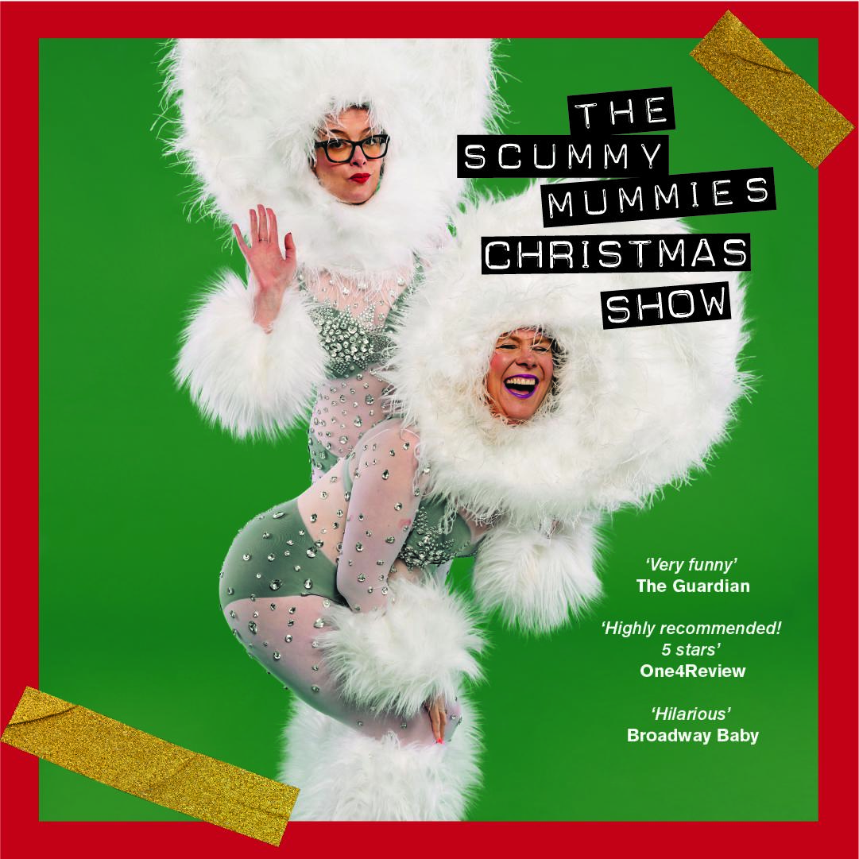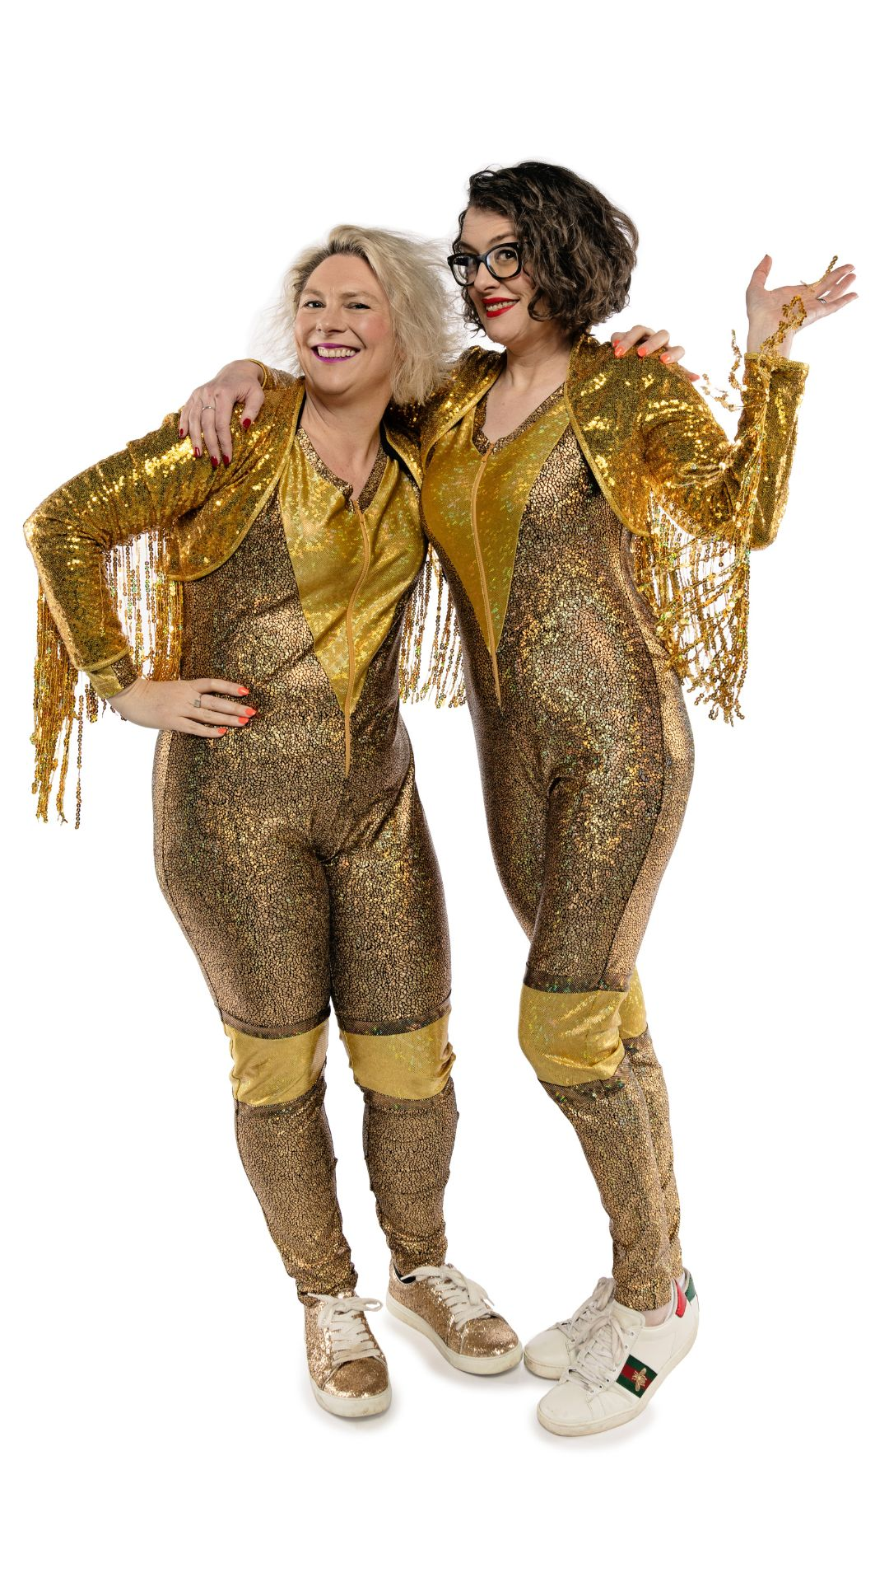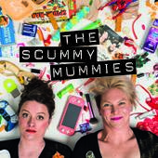

Ellie Gibson and Helen Thorn joined forces to become The Scummy Mummies in July 2013. They have since gone on to produce an award-winning podcast, a sell-out touring comedy show, a popular book, and recently achieved a Guinness World Record for the highest ever stand-up comedy gig on land. They have an ever-growing social media presence, with more than 172k on [Instagram](https://www.instagram.com/scummymummies).

There are now over 300 episodes of The Scummy Mummies Podcast, and they have been downloaded more than 7 million times in 150 countries. The show has featured in “Best Podcast” lists in The Guardian, the Sunday Times, and The Telegraph. It has been nominated for a British Podcasts Award plus Mixcloud and Lovies awards, and in 2020 won the Glomama UK Best Podcast trophy. Guests have included comedians such as Dara O Briain, Jenny Eclair, and Thanyia Moore; influencers like Giovanna Fletcher, Mother Pukka, Rosie Ramsey, and Louise Pentland; plus a wide range of experts on everything from mental health, politics, and entrepreneurship to parenting, wine, and sex.

The Scummy Mummies also perform a hit live comedy show packed with sketches, songs, and top quality boob jokes. In 2019 they made their Edinburgh Festival debut, selling out the entire 25-night run and earning a five-star review. They were also featured in three *Top 50 Jokes of the Fringe* lists.

Helen and Ellie continued to perform to packed festival crowds and theatre audiences around the country, regularly selling out 500-800 seater venues, usually wearing their trademark gold catsuits. Their record for selling out an entire show from the time tickets go on sale is 9 minutes.

In March 2023, the double act trekked to Mount Everest Base Camp raising over £15,000 for the Borne Premature Baby Charity, and performed a 32 minute stand-up show to an audience of Sherpas, Everest specialist workers and 3 of their mates. It was -15 degrees, but they still managed to wear their gold catsuits, much to the surprise of the onlookers! It is there they broke the Guinness World Record.

Their first book, *Scummy Mummies*, was released in March 2017 and reached the top 20 on the Amazon chart. It went to number one in the *Child Discipline* category, weirdly. Ellie and Helen have also written for *The Guardian*, *The Telegraph*, *Metro*, *Glamour, Red* and more.

The Scummy Mummies have featured on ITV’s *Lorraine*, *Steph’s Packed Lunch*, *Good Morning Britain*, *Victoria Derbyshire*, *The Wright Stuff*, *Sky News*, and in Australia, *The Morning Show* and *Sunrise*. Radio appearances include BBC Radio 4 (*Woman’s Hour*, *Broadcasting House*, *Today*), Radio 2, Radio 5 Live, Radio 1 and Radio 6 Music.

Corporate work has included hosting, presenting and performing at events for NOW TV, BAFTA Games, English Heritage, Sony PlayStation, the Royal College of Midwives, The Baby Show, Stylist Live, Mumsnet, and Channel Mum.

The Scummy Mummies have worked with brands including Google, PayPal, Hello Fresh, Sainsbury's, Marks & Spencer, Asda, Co-op, McCain, Birdseye, Natwest, Nectar, Channel 4, Kleenex, TENA, Emirates, Moonpig, Hasbro, Clarks, Ella’s Kitchen, and many more.

Ellie is also an award-winning games journalist. She appeared as the games expert on hit Dave show *Dara O Briain's Go 8 Bit*. She presented the spin-off, *Go 8 Bit DLC*, and was the first woman ever to host a show on Dave. Together with The Guardian’s Keza MacDonald, she co-hosts the Extra Life games podcast. She recently launched a new video games-focused Instagram account @elliegibsongames, is on Twitter @elliegibson, and streams most Tuesday and Friday nights at Twitch.tv/elliegibsongames.

Helen is a Sunday Times Bestselling author. Her debut book, *Get Divorced, Be Happy*,was an instant hit. She performed a sell-out run of her solo stand-up show, *Thorny Questions*, at the 2017 Melbourne International Comedy Festival. She also hosted 2 series of her own hit podcast, *Fat Lot of Good*. Her fashion and fitness Instagram account, @itsmehelenthorn, has over 65k followers. She has completed 10 marathons and has completed the six marathon world majors.

**CURRENT SOCIAL MEDIA STATS**

Instagram followers: 172k

Monthly impressions: 1.8 million

Monthly reach: 150k accounts

Twitter followers @scummymummies: 13.6k

Twitter followers @elliegibson: 16.8k

Instagram followers @itsmehelenthorn: 65k

Instagram followers @itsmeelliegibson: 11k

Facebook followers @scummymummies: 34k

Podcast downloads: approx. 40k per month

Lifetime downloads: 7 million-plus

For more about Helen and Ellie, to listen to their podcast or find out details of their live shows, visit [www.scummymummies.com](http://www.scummymummies.com).

Instagram: @scummymummies

Twitter: @scummymummies

Facebook: facebook.com/scummymummiespodcast

Website: scummymummies.com / scummymummiesshop.com

"Hilarious" - *Broadway Baby* "Utterly brilliant" - *Camp Bestival*  
"Very funny" *- The Guardian* “Highly recommended - 5 stars” - *One4Review*  
"Worryingly competent"*- Jane Garvey, Radio 4's Woman’s Hour*