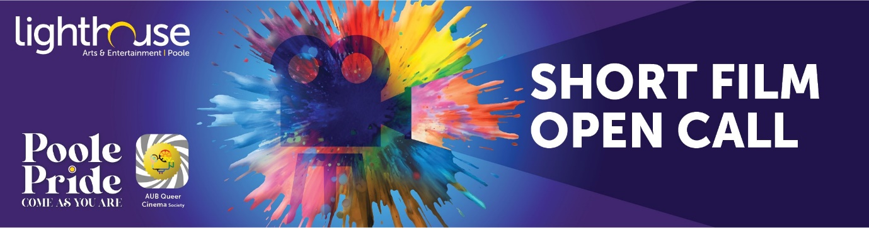

OPEN CALL FOR LGBTQ+ FILMMAKERS
Thank you for entering our open call for LGBTQ+ filmmakers in Dorset.
Before we review your entry, we would love to know more about you!
We aren’t looking for anything too lengthy, just something that let’s us know more about the brilliant mind behind the lens.

Name:
Age:

Tell us about yourself (100 words or less):

Movie title:
Movie credits:

Movie synopsis (100 words or less):

Link to Dropbox / Google Drive / WeTransfer download:

To submit your entry, please fill out the attached form, include a link for us to download your short film and return to Ashton.corbin@lighthousepoole.co.uk.
It is also possible to submit your films by post on a flash drive to:
Poole Pride Short Film Open Call
Lighthouse
21 Kingland Road
Poole
Dorset BH15 1UG

