Theatre reviewRead all about it!
THURSDAY, MARCH 21, 2024

Theatre reviewRead all about it!

Theatre reviewRead all about it!

Theatre reviewRead all about it!

Theatre review

Theatre review Read all about it! | Morning Star (morningstaronline.co.uk)

LYNNE WALSH recommends an outstanding production with the zeal to tell stories of our socialist past
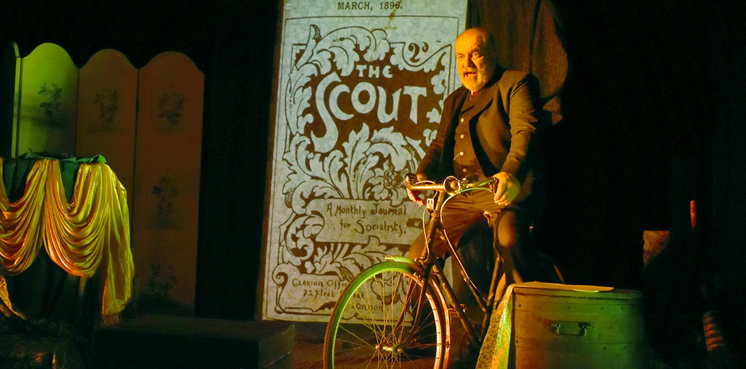

MASTERY: Neil Gore in Behold Ye Ramblers Photo: Daniella Beattie

Behold Ye Ramblers
Sands Film Studio
THREE things stand out in this exhilarating show: the power of song, the zeal to tell stories of our socialist history, and the mastery demanded of the solo artist.
Townsend Theatre productions are invariably politically motivated, yet their narratives of class struggle are always twinkled through with humour and plenty of audience participation.
Their aim here is to bring us the astonishing tale of the Clarion newspaper, and the social movement it spawned. Founder and journalist Robert Blatchford started the paper in 1891, out of his own pocket. At its height, it sold between 30,000 and 70,000 copies a week. Contributors included Rebecca West, George Bernard Shaw and Walter Crane.
Neil Gore, who has written much of the music for the show, kick-starts the piece with a fine homage to the old TV favourite, The Good Old Days. Within a minute, we are singing along, belting out I Live in Trafalgar Square. The creation of music hall atmosphere is immediate and organic. I’d have been quite happy to wear a bonnet.
There are some big themes here: exploitation of workers forced to toil in grim conditions, the power of a popular newspaper to spread the word of socialism, the right to enjoy the countryside. Rambling is a defiant act.
Songs are both old and new, seamlessly interwoven. Gore takes text from the Clarion itself, in which Blatchford railed against the pitiful conditions of “Poor Women Shirt-Makers.” The song is accompanied by grainy images of the exploited workforce: it’s visceral stuff.
Gore channels Blatchford again, in a polemic against conditions in the chemical works of St Helens. The foreman advises the journalist not to venture onto the factory floor, warning the effect would be like swallowing boiling water mixed with quicklime.
It’s testimony to Gore’s abilities that it is entirely believable that we’re witnessing two characters on stage. As for the St Helens foreman, the Scouser sitting beside me said: “That accent is really good!”
The production is joined on its tour by several socialist “vocal unions”; on this occasion, the Strawberry Thieves choir. One piece, The People to their Land, is both melancholy and rousing — the Right to Roam was a core of the Clarion movement’s beliefs. It was thrilling to hear this work by social reformer Edward Carpenter.
The breadth of the Clarion influence is breathtaking, with cycling clubs, choirs and bands, rambling clubs and drama groups. The years may have dimmed them, but Clarion Cyclists and choirs still thrive.
What Townsend do so beautifully is to bring to life the stories of firebrand pioneers, who still speak to us now. We must heed their clarion call.

On tour until June 7. For more information see: townsendproductions.org.uk

